44-563 Developing Web Applications and Services Spring 2013

Exam 1

*Questions 1-9 refer to the web page shown below.*

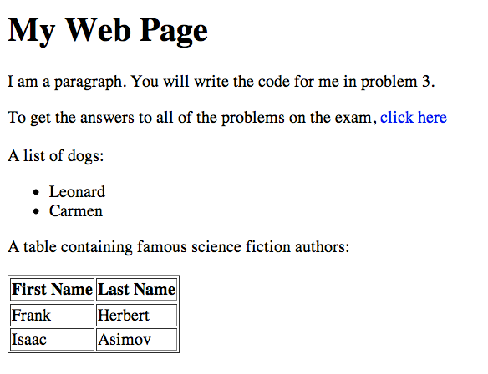

1. (6 pts) Write the HTML code (including the necessary tags) to set the title of the web page to “Exam One”.

<title>Exam One</title>

2. (6 pts) Write the HTML code (including the necessary tags) for the heading “My Web Page”.

<h1>My Web Page</h1>

3. (6 pts) Write the HTML code (including the necessary tags) for the paragraph.

<p>I am a paragraph. You will write the code for me in problem 3.</p>

4. (6 pts) Write the HTML code (including the necessary tags) for the list of dogs.

<ul>

<li>Leonard</li>

<li>Carmen</li>

</ul>

5. (10 pts) Write the HTML code (including the necessary tags) for the table containing names of science fiction authors.

<table border="1">

<thead>

<tr>

<th>First Name</th>

<th>Last Name</th>

</tr>

</thead>

<tbody>

<tr>

<td>Frank</td>

<td>Herbert</td>

</tr>

<tr>

<td>Isaac</td>

<td>Asimov</td>

</tr>

</tbody>

</table>

6. (5 pts) Write the HTML code (including the necessary tags) to add a picture to the web page. Assume the name of the picture file is “mynewdog.jpg” and the file is located in the same directory as the .html file for the web page.

<img src="mynewdog.jpg" alt="My New Dog" />

7. (6 pts) Write the HTML code (including the necessary tags) for including the link click here to another web page. Assume the URL of the other web page is

http://cshelp.org/exam1key.html

<a href=<http://cshelp.org/exam1key.html>>click here</a>

8. (5 pts) Write CSS code to set the background color of the page to yellow.

body {

background-color: yellow;

}

9. (5 pts) Write CSS code set the color of the text in the paragraph to red.

p {

color: red;

}

10. (a) (5 pts) Assume a web page contains an element with id = "mydog". Write CSS code to display this element in the color green.

#mydog {

color: green;

}

(b) (5 pts) Assume a web page contains one or more elements that have class="abc". Write CSS code to display all of these elements in blue.

.abc {

color: blue;

}

11. (12 pts) Answer the questions below concerning this definition from a schema:

<xsd:complexType name="Items">

<xsd:sequence>

<xsd:element name="item" minOccurs="1" maxOccurs="6">

<xsd:complexType>

<xsd:sequence>

<xsd:element name="productName" type="xsd:string"/>

<xsd:element name="quantity">

<xsd:simpleType>

<xsd:restriction base="xsd:positiveInteger">

<xsd:maxExclusive value="5"/>

</xsd:restriction>

</xsd:simpleType>

</xsd:element>

<xsd:element name="USPrice" type="xsd:decimal"/>

<xsd:element ref="comment" minOccurs="0"/>

<xsd:element name="shipDate" type="xsd:date" minOccurs="0"/>

</xsd:sequence>

<xsd:attribute name="partNum" type="SKU" use="required"/>

</xsd:complexType>

</xsd:element>

</xsd:sequence>

</xsd:complexType>

<xsd:simpleType name="SKU">

<xsd:restriction base="xsd:string">

<xsd:pattern value="\d{2}[A-Z]{3}\d{2}"/>

</xsd:restriction>

</xsd:simpleType>

(a) The **item** element can be omitted.

TRUE FALSE

(b) The **item** element can occur 7 times.

TRUE FALSE

(c) The **shipDate** element is required.

TRUE FALSE

(d) The value of **quantity** can be 0.

TRUE FALSE

(e) The maximum legal value of **quantity** is ___4_______.

(f) Give an example of a legal value for **partNum**. 38DFW72

12. Assume we are using Java to parse the xml document below.

<?xml version="1.0" encoding="UTF-8"?>

<!DOCTYPE student SYSTEM 'student.dtd'>

<student studentNumber="S24">

<name>

<first>Midge</first>

<last>McDonald</last>

</name>

<courseList>

<course>

<courseNumber>44-100</courseNumber>

<grade>84</grade>

</course>

<course>

<courseNumber>44-200</courseNumber>

<grade>93</grade>

</course>

<course>

<courseNumber>44-123</courseNumber>

<grade>89</grade>

</course>

</courseList>

</student>

(a) (3 pts) In order to extract the last name for the student, we would use the expression (write the appropriate value for the first argument ***below*** the method call):

path.evaluate(" ", doc)

/student/name/last

(b) (5 pts) In order to extract the course number for the first course, we would use the expression:

path.evaluate(" ", doc)

/student/courseList/course[1]/courseNumber

(c) (5 pts) In order to extract the grade for the third course, we would use the expression:

path.evaluate(" ", doc)

/student/courseList/course[3]/grade

13. (10 pts) An XML language for representing appointments is defined by the following DTD:

<?xml version="1.0" encoding="UTF-8"?>

<!ELEMENT appointmentList (appointment+)>

<!ELEMENT appointment (date, time, description)>

<!ELEMENT date (day, month, year)>

<!ELEMENT day (#PCDATA)>

<!ELEMENT month (#PCDATA)>

<!ELEMENT year (#PCDATA)>

<!ELEMENT time (start, end)>

<!ELEMENT start (#PCDATA)>

<!ELEMENT end (#PCDATA)>

<!ELEMENT description (#PCDATA)>

Write an XML file that uses the appointments language to represent the data described below.

There will be an ACM meeting on March 25, 2013, from 17:30 to 18:30.

<appointmentList>

<appointment>

<date>

<day>25</day>

<month>March</month>

<year>2013</year>

</date>

<time>

<start>17:30</start>

<end>18:30</end>

</time>

<description>ACM Meeting</description>

</appointment>

</appointmentList>

ADDITIONAL SPACE

**DO NOT REMOVE THIS PAGE**

ADDITIONAL SPACE

**DO NOT REMOVE THIS PAGE**